**Based On SAT Writing Real Test (March 2018)**

**Vocabulary**

**I.**      **Arable - Arable farming land is used for, or is suitable for, growing crops.**

Sentence example - The country is rich in arable land.

**II.**      **Irrigation - the practice of supplying land with water so that crops and plants will grow.**

Sentence example - Dirty irrigation water can spread animal pathogens to fruits and vegetables.

**III.**  **Unease - a feeling of being worried about something.**

Sentence example - The security lapses have caused widespread unease amongst air passengers.

**IV.**  **Misgiving - a feeling of doubt or worry about a future event.**

Sentence example - Many teachers expressed serious misgivings about the new tests.

**V.**      **Noble - moral in an honest, brave, and kind way.**

Sentence example - His followers believe they are fighting for a noble cause.

**VI.**  **Anguish - extreme unhappiness caused by physical or mental suffering.**

Sentence example - His anguish at the outcome of the court case was very clear.

**VII.**      **Strive - to try very hard to do something or to make something happen, especially for a long time or against difficulties.**

Sentence example - In her writing she strove for a balance between innovation and familiar prose forms.

**VIII.**      **Dicey - slightly dangerous or uncertain.**

Sentence example - The company's finances look a little dicey.

**IX.**  **Disengaged - not feeling interested or involved in something.**

Sentence example - People are becoming disengaged from the democratic process.

**X.**      **Discernment - the ability to judge people and things well.**

Sentence example - It's clear that you are a person of discernment.

**MELTZER 12**

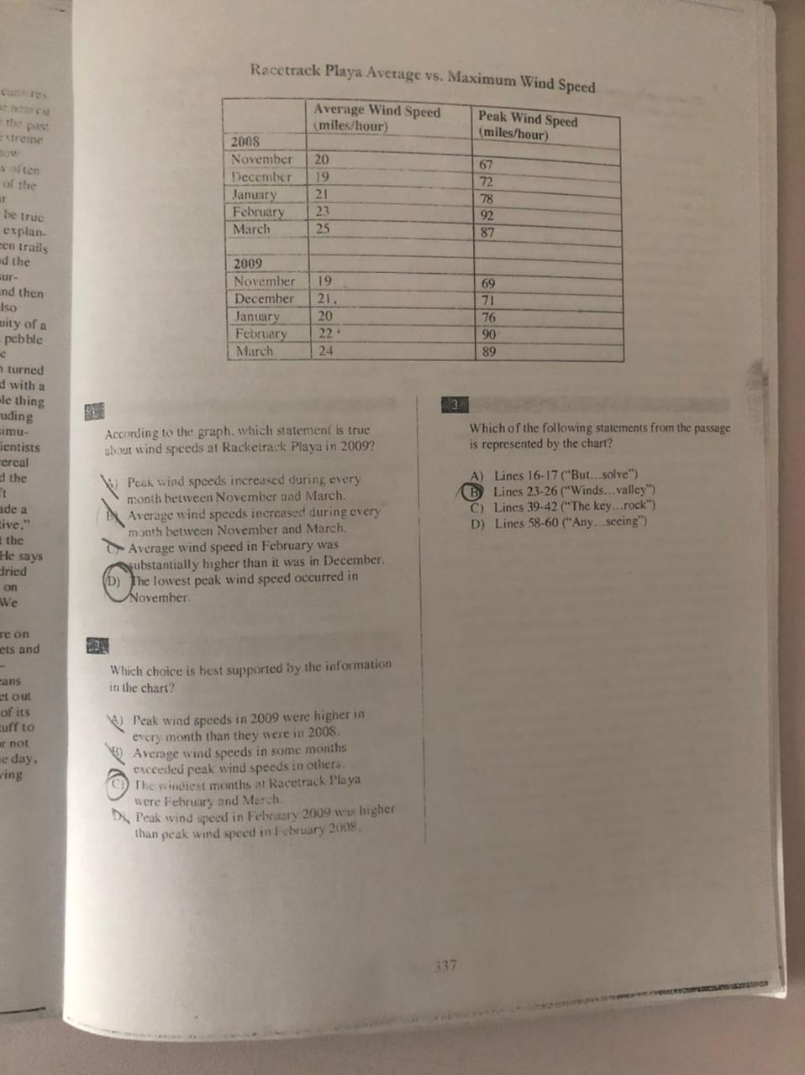

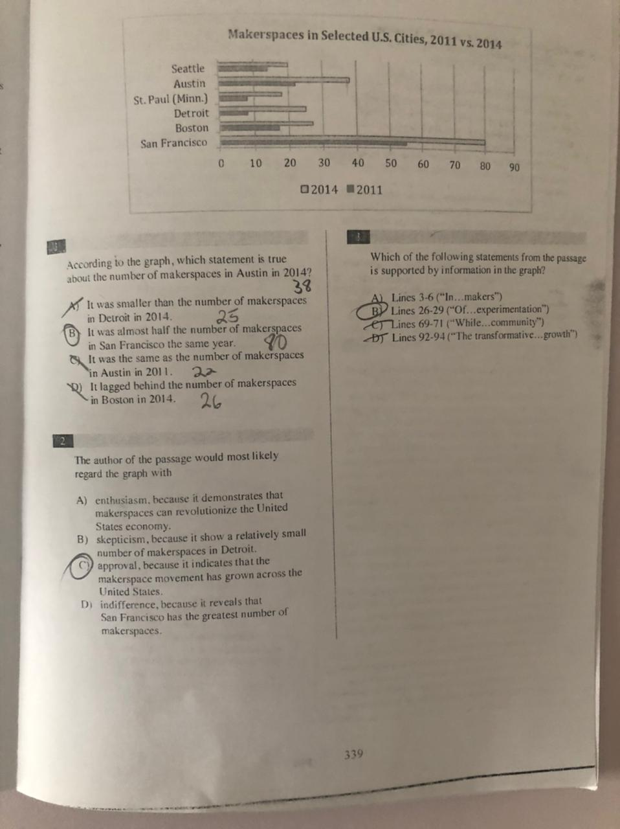

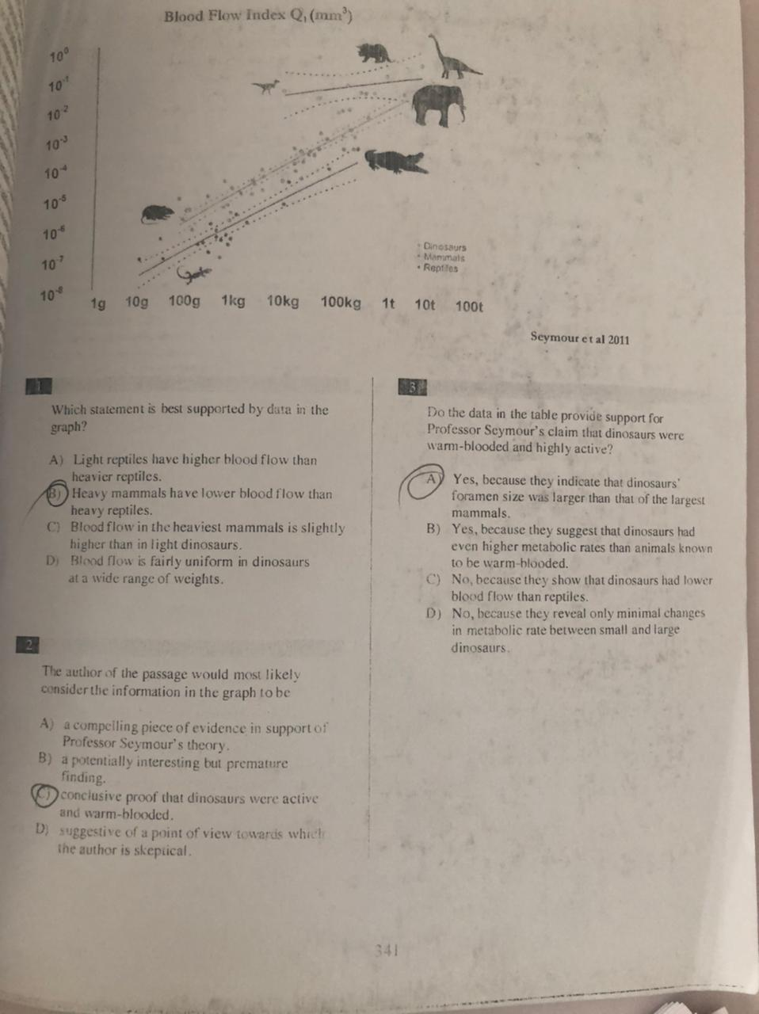  
  
**SAT Writing Real Test (March 2018)**

1. **C**
2. **D**
3. **D**
4. **C**
5. **A**
6. **C**
7. **A**
8. **A**
9. **B**
10. **B**
11. **D**
12. **D**
13. **C**
14. **C**
15. **B**
16. **D**
17. **A**
18. **D**
19. **A**
20. **A**
21. **B**
22. **B**
23. **B**
24. **C**
25. **B**
26. **D**
27. **C**
28. **B**
29. **A**
30. **B**
31. **C**
32. **C**
33. **A**
34. **A**
35. **D**
36. **D**
37. **B**
38. **C**
39. **B**
40. **B**
41. **D**
42. **C**
43. **B**
44. **A**

**SAT (Reading) Real Test (March 2018) Answers**

**1.**  **C**

**2.**  **D**

**3.**  **B**

**4.**  **D**

**5.**  **B**

**6.**  **B**

**7.**  **C**

**8.**  **A**

**9.**  **A**

**10.**           **C**

**11.**           **C**

**12.**           **A**

**13.**           **A**

**14.**           **D**

**15.**           **D**

**16.**           **B**

**17.**           **B**

**18.**           **C**

**19.**           **B**

**20.**           **D**

**21.**           **D**

**22.**           **B**

**23.**           **A**

**24.**           **A**

**25.**           **-**

**26.**           **D**

**27.**           **D**

**28.**           **D**

**29.**           **-**

**30.**           **-**

**31.**           **B**